**NEO-NATAL KNITTED CAP**

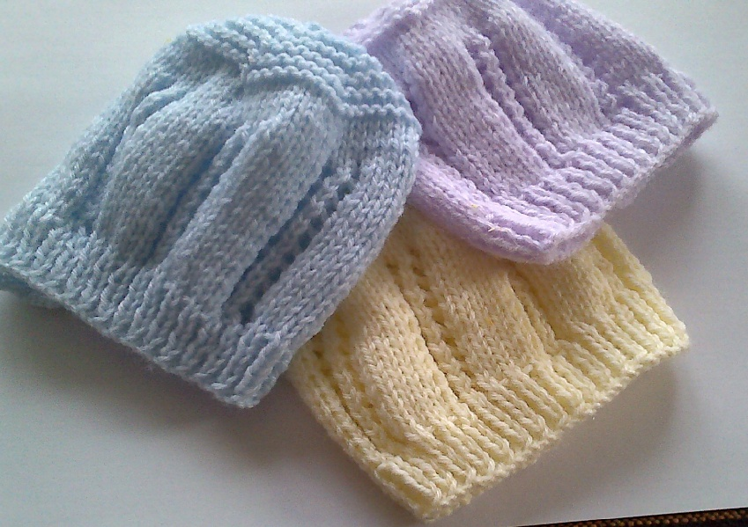

Use 4ply baby wool in pastel shades

3.25mm knitting needles

Cast on 69 stitches

Work 6 rows in K1 P1 rib

Work 18 rows in pattern:

1. K3 (wfd K2 tog, wfd K2 tog K 5) to last 3 stitches, K3
2. Purl

Then work 4 rows in stocking stitch

TO SHAPE CROWN – Working in garter stitch

Row 30 K7 K2 tog to last 6 sts. K6

Row 31 and alternate rows knit (plain)

Row 32 K6 K2 tog to last 6 sts. K6

Row 34 K5 K2 tog to last 6 sts. K6

Row 36 K4 K2 tog to last 6 sts. K6

Row 38 K3 K2 tog to last 6 sts. K6

Row 40 K2 K2 tog to last 6 sts. K6

Row 42 K1 K2 tog to last 6 sts. K6

Draw thread through remaining stitches and finish off seam.